DIVISION OF bAMBOO FLOORING HAWAII LLC.
Ali’I Collection

SPC LVT RIGID CORE

INSTALLATION INSTRUCTIONS

SUITABLE SURFACES
Lightly textured or porous surfaces. Well bonded, solid floors. Dry, clean, well-cured concrete (cured for at least 60 days prior). Wood floors with plywood on top. Ceramic or porcelain tiles with grout lines filled with floor
leveler. All surfaces must be clean and dust free.

UNSUITABLE SURFACES
Rough, uneven surfaces including carpet and underlay. This product is not suitable for rooms that could potentially flood, or rooms that have damp concrete or saunas. Do not install this product in areas which are exposed to long term direct sunlight such as sun rooms or solariums.
WARNING: DO NOT REMOVE OLD RESILIENT FLOORING. THESE PRODUCTS MAY CONTAIN EITHER ASBESTOS FIBERS OR CRYSTALLINE SILICA, WHICH CAN BE HARMFUL TO YOUR HEALTH.

PREPARATION
The Rigid Core planks should be allowed to acclimatize at room temperature (approx. 68°F/20°C) for 48 hours prior to installation.
Carefully check planks for any defects before installation. Any plank that has been installed will be deemed acceptable by the installer.
Check that all ITEM NUMBERS are the same and that you have purchased sufficient material to complete the job. Remove any traces of glue or residue from the previous flooring.
New concrete floors need to dry out for at least 60 days prior to installation. All nail heads must be driven down below the surface. Securely nail all loose boards. Scrape, plane or fill uneven boards, holes or cracks using a floor leveling compound if subfloor is uneven - over 1/8" (3.2 mm) within a span of 4' (1.2 m). If installing over existing tile, use a floor leveling compound to skim coat grout lines. Make sure the floor is smooth, clean, and free of wax, grease, oil or dust, and sealed as necessary before laying planks.
The maximum run length is 60' (18.29 m). For areas beyond 60' (18.29 m), the floor will require transition strips

TOOLS AND SUPPLIES
Saw, tapping block, rubber mallet, spacers, pencil, tape measure, ruler and safety goggles.

INSTALLATION
Diagram 1. Start in a corner by placing the first plank with the tongue side facing the wall. Use spacers along each wall to maintain an expansion space of 3/8"-1/2" (8-12 mm) between the wall and the flooring.
NOTE: This spacing must also be maintained between the floor and all vertical surfaces, including cabinets, posts, partitions, door jambs and door tracks.
Diagram 2. To attach your second plank, lower and lock the 5-Gi Push Down end tongue of the second plank into the end groove of the first plank. Line up edges carefully to ensure a close and tight fit. Using a rubber mallet, lightly tap the top of the end joints where the first and second planks lock together. The planks should lay flat to the floor. See video: https://www.5gfolddown.com/download/. WARNING: FAILURE TO PROPERLY LINE UP THE 5 Gi PUSH DOWN END JOINT AND ATTEMPTING TO FORCE IT IN WHILE OUT OF ALIGNMENT COULD RESULT IN PERMANENT DAMAGE TO THE END JOINT.
Repeat this procedure for each subsequent plank in the first row. Continue connecting the first row until you reach the last full plank.
Diagram 3. Fit the last plank by rotating the plank 180° with the pattern side upward and placing it beside the first row of planks with its end up against the far wall. Line up a ruler across the end of the last full plank and across this new plank. Draw a line across the new plank with a pencil and cut with a saw.
Rotate the plank 180° so that it is back to its original orientation. Lower and lock its end tongue into the end groove of the last full plank. Lightly tap the top of the end joints with a rubber mallet until the planks are flat on the floor.
Diagram 4. You will begin the next row with the off-cut piece from the previous row to stagger the pattern. Pieces should be a minimum of 8" (200 mm) long and joint offset should be at least 8" (200 mm). Cut pieces should be no less than 3" (76.2 mm) in width. Adjust layout for a balanced look.
Diagram 5. To start your second row, tilt and push the new plank's side tongue into the side groove of the very first plank. When lowered, the plank will click into place. Using a tapping block and rubber mallet, lightly tap the long side of the new plank to lock it with the planks of the first row. The planks should lay flat to the floor.
Attach the second plank of the new row first on the long side. Tilt and push plank into place, making sure edges are lined up. Lower plank to the floor. Using a tapping block and rubber mallet, lightly tap the long side of the new plank to lock it into place. Next, lightly tap down on the top of the 5 Gi Push Down end joints with a rubber mallet to lock them together. Continue laying remaining planks in this manner.
Diagram 6. To fit the last row, lay a plank on the top of the previous row with its tongue to the wall. Lay a ruler across the plank so that it is lined up with the side of the planks of the previous row and draw a line across the new plank with a pencil. Don't forget to allow room for spacers. Cut the plank with a saw and attach into position.
Diagram 7. Door frames and heating vents also require expansion room. First cut the plank to the correct length. Then place the cut plank next to its actual position and use a ruler to measure the areas to be cut out and mark them. Cut out the marked points allowing the necessary expansion distance on each side.
Diagram 8. You can trim for door frames by turning a plank upside down and using a handsaw to cut away the necessary height so that planks slide easily under the frames. Remove the spacers once the floor is completely installed.

CARE AND MAINTENANCE
Rigid Core planks can withstand topical water and water penetration without damage. Water leakage over or around the outer edges of the flooring, however, can damage a wood subfloor, so clean up water as soon as possible. Excessive water underneath the flooring, while not causing damage to the flooring itself, could become trapped under the flooring. Any issues with a wet or damp concrete floor should be addressed before the installation of any flooring.
Sweep regularly to remove surface grit and dust. Use a damp cloth or mop to clean up any dirt and footprints.
CAUTION: Planks are slippery when wet.
Never use wax, polish, abrasive cleaners or scouring agents as they may dull or distort the finish.
High heels can damage floors. Do not allow pets with unclipped nails to scratch or damage the floor. Use protective pads under furniture. Use doormats at entranceways to protect the floor from discoloring. Avoid using rubber-backed rugs, as they may stain or discolor the Rigid Core flooring. If you have an asphalt driveway, use a heavy-duty doormat at your main door, as chemicals in asphalt can cause Rigid Core flooring to yellow.
Avoid exposure to direct sunlight for prolonged periods of time. Use drapes or blinds to minimize direct sunlight during peak sunlight hours.
Save a few planks in case of accidental damage. Planks can be replaced or repaired by a flooring professional.
If other trades are in the work area, a floor protector is highly recommended to help protect the finish of the floor.
CAUTION: Some types of nails, such as common steel nails, cement coated or resin-coated nails, may cause a discoloration of the Rigid Core floor covering. Use only non-staining fasteners with underlayment panels. The procedure of gluing and screwing underlayment panels is not recommended. Solvent-based construction adhesives are known to stain Rigid Core floor coverings. The installer and/or consumer is responsible for any discoloration problems caused by fastener staining or the use of construction adhesives.

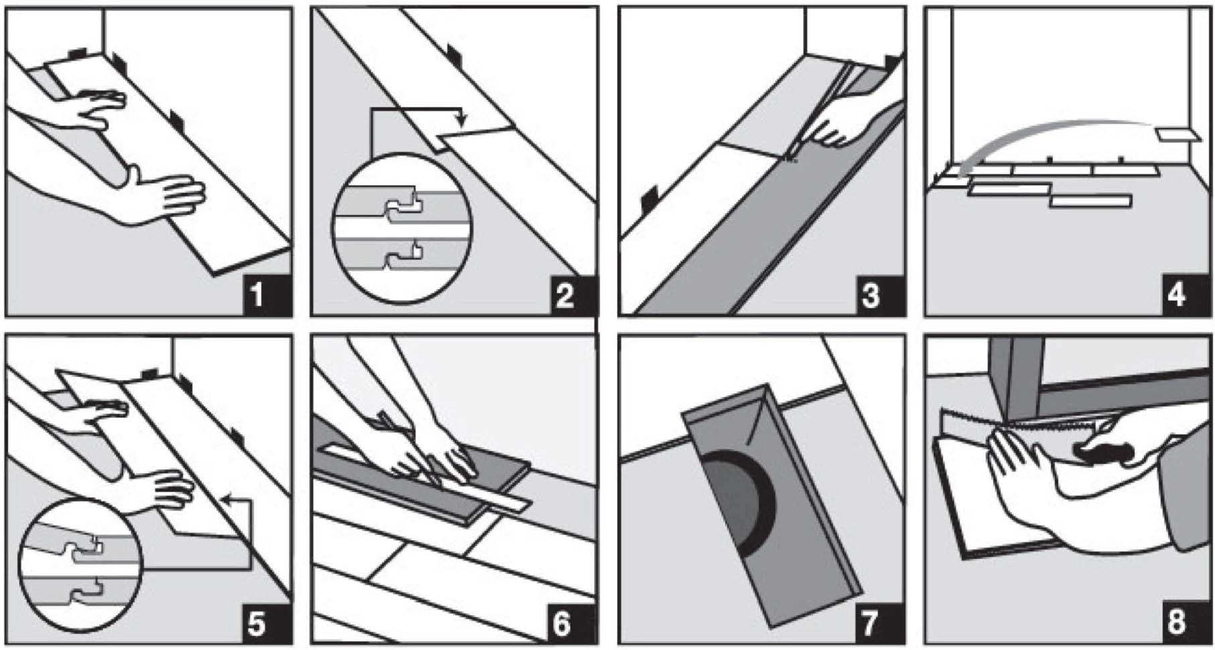

DIVISION OF bAMBOO FLOORING HAWAII LLC.
Ali’I Collection

SPC LVT RIGID CORE

Exclusive Limited Warranty

Hawaiian Style Luxury Vinyl Tile SPC LVT Alli’I Collection, division of BFH, warrants that its products are free from any visual or manufacturing defects. If the Products are found to be defective, BFH will supply new Product of the same or similar style, size, color, grade, and gauge to repair or replace the defective area and will pay reasonable labor costs provided the flooring is professionally installed and maintained according to the installation instructions provided. Products that are non-defective but are damaged during an improper installation would not constitute a valid claim as defined by this limited warranty. BFH reserves the right to inspect any claim and/or request photographs and/or samples associated with the specific claim prior to approving any claim. All limited warranties are valid for the original purchaser of the flooring and are not transferrable. It does not cover damage from improper installation or maintenance (including side or end gapping), tears, indentations, stains or reduction in gloss level due to normal use and/or exterior applications. Gapping, shrinkage, squeaks, fading or structural subfloor related issues are not covered under this warranty. Temperature variations - excessive heat (100°F or 37.8°C and above) or below freezing (32°F or 0°C and below) – may cause expansion or contraction of the product.

Pre-Installation Visual Limited Warranty

BFH warrants that this product is free from visual defects. All Products purchased for an installation should be inspected by you and/or your installer. Pieces that appear to be visually defective should not be installed. BFH will not be responsible for reimbursing labor charges on any claim for visually defective product installed. It is the responsibility of the installer to determine the suitability of the product for installation before it is installed. If a problem occurs during the installation of the flooring, the job should be stopped immediately. The proper action is to immediately report the problem to your dealer or contact BFH immediately. Any costs caused by continued installation after the problem is reported will not be covered by BFH.

Wear Limited Warranty

Hawaiian Style Luxury Vinyl Tile division of BFH, SPC LVT flooring is protected with a wear layer. BFH warrants that there will be no wear-through of the wear layer for the number of years indicated for the specific product. “Wear-through” means complete loss of the wear layer so that the printed color layer is changed or affected. The term for your specific product wear Limited Warranty will appear on the insert of the product you purchased. This Limited Warranty only applies provided the recommended installation and maintenance procedures are followed as outlined in the Installation Instructions and Owner’s manual.

Specific wear warranties are:
Wear Layer | Residential | Commercial
20 mil | Lifetime | 10 Years
Waterproof Limited Warranty

Hawaiian Style Luxury Vinyl Tile SPC LVT flooring is warranted to be 100% waterproof. The structural performance of this flooring will not be adversely impacted by water exposure for the life of the product. Mold and/or mildew can sometimes occur in a building if moisture issues are not addressed. This moisture warranty excludes damage resulting from the growth of both mold and/or mildew due to extended moisture exposure. Structural damages to the SPC LVT flooring found caused by water will be subject to a pro-rated credit as described below in the “Terms of Lifetime Limited Warranty” section.

Waterproof Limited Warranty does not cover:

- Any damage to structures that are not part of the installed SPC LVT flooring such as damage to surrounding walls, subfloor, structures, fixtures, furniture, underlayment, moldings, trims, and subfloor heating systems.

- Any damage from mold and/or mildew growth due to extended water exposure.

- Flooring that is installed outdoors.

Lifetime Residential Limited Warranty

Our Lifetime Residential Limited Warranty for SPC LVT plank flooring means that from the date of purchase, your floor will be free from manufacturing defects and will not wear through or permanently stain from common household stains when installed and maintained according to instructions supplied with each carton.

10 Year Light Commercial Limited Warranty

Our 10-year Light Commercial Limited Warranty for SPC LVT plank flooring means that for 10 years, from the date of purchase, your floor will be free from manufacturing defects and will not wear through or permanently stain from common household stains when installed and maintained according to instructions supplied with each carton.

Terms of Limited Lifetime Warranties

Claims reported on material defects of any WPC LVT or SPC LVT flooring will be prorated over the life of the product. Reasonable labor costs will be paid with the following exceptions:
- Claims reported after 1 year of use will pay labor charges at the rate of 50% reasonable labor charges.
- Claims reported after 5 years of use will not pay labor charges.

Steam Cleaners

BFH does not recommend the use of any type of steam cleaner on our floors. These types of cleaners generate too much moisture and heat during their use. The resulting moisture and heat can be enough to break down any adhesives used in the manufacturing of this product. Also, in instances where no glue is used, both peaked and swelled plank or tile edges can occur. Therefore all complaints that are determined to be from a consumer using a steamer will be denied by Hawaiian Style Luxury Vinyl Tile division of BFH.

Bamboo Flooring Hawaii
521 Ala Moana Blvd #213
Honolulu, HI 96813
808-550-8080
bambooflooringhi@aol.com
bambooflooringhawaii.com

Division of Bamboo Flooring Hawaii, LLC

CUSTOMER INFORMATION
Name: _________________________________________________________________________________________________________________________

Address: ______________________________________________________________________________________________________________________

City:_________________________________________________________________________State: _____________________ Zip: ________________
Property Type: ______________Residential _______________Commercial
________________Remodel ___________ New Construction

INSTALLER INFORMATION
Installer: ______________________________________________________________________________Contractors License #___________
Address: ___________________________________________________________________________Phone: ________________________________
To validate warranty, please record the installation information below.
Type of Floors: ___________________________________________________

Installation: Glue Down_____ Floating_____

INSTALLATION
Date to site: _____________________________________ Acclimation ________days Date Installed: ___________________________

INTERIOR EVALUATION

Area Temperature: ________________ Capable of Mimicking Expected Living Conditions: ______Yes ______No
Note concerns: ______________________________________________________________________________________________________________

SUBSTRATE EVALUATION

Type: Concrete _____________________Wood__________________ Grade: ________Above __________Below
Moisture Meter Used: _____ RH _____ Meter _____ CaCI _____Other_____Results: __________________________________
Please attach photo of results.
Note concerns: ______________________________________________________________________________________________________________

INSTALLATION

Method of install: ___________________________________Adhesive used: ________________________________ Yes _____ No ______
Underlayment used:________________________________ Yes _____ No ______
Moisture Barrier used: ____________________________ Yes _____ No ______ # of coats used:________________________
Expansion space used: _____________________________ Moldings used:__________________________________

NOTES _________________________________________________________________________________________________________________________________

Bamboo Flooring Hawaii
521 Ala Moana Blvd Suite 213
Honolulu, HI 96813
Ph: (808) 550-8080 Email: bambooflooringhi@aol.com
www.bambooflooringhawaii.com
Ali’i Collection

spc LVT rigid floors

Daily / Regular Maintenance

• Use a damp cloth to blot up spills immediately to prevent stains.
• Sweep, dust, or vacuum with the hard surface attachment regularly to prevent dirt and debris from accumulating-this can scratch or dull your floor’s finish
• Damp mop as needed with clean water and nonabrasive floor cleaner
• As needed, clean the floor with product specifically made for vinyl/spc floors by lightly spraying the product on to a terry cloth or microfiber mop.

Avoid
• Do not vacuum with a beater bar as it may scratch or dent your floor
• Never use soap, wax, or oil based detergents-they may dull the finish or leave a greasy film making the floors slippery and harder to clean.
• Do not use abrasive cleaners, steel wool, or strong ammoniated or chlorinated cleaners
• Do not use steam cleaners or buffing/polishing machines.

Extra Protection
• Protect your floor against direct sunlight or any intense source of artificial light, over time excessive light may discolor the floors. Block heat & fade-causing UV rays with protective window coverings and rearrange rugs and furniture periodically to help your floor age evenly.
• Invest in quality floor mats to help trap grit and absorb moisture at entry points. Mats should also be placed in high traffic areas as way to reduce wear. Protective mats must be used for furniture or chairs with castors.
• Add non-staining protective pads to all furniture and chair legs for an extra layer of defense against indentations and scratches, replace them once they are worn or dirty. Generally, the heavier the object, the wider the floor protector-never slide furniture across the floor
• Keep your pet’s nails trimmed to prevent them from scratching the floor
• Maintain a normal indoor temperature throughout the year

Tips
• Use isopropyl alcohol with a clean white cloth for spots requiring a solvent type cleaner that water and cleaning agents can’t remove
• Tough substances can be gently scraped with a plastic scraper and dried spots should be removed by gentle agitation, rinsed with water, and blot dried

Bamboo Flooring Hawaii
521 Ala Moana Blvd Suite 213
Honolulu, HI 96813
Ph: (808) 550-8080 Email: bambooflooringhi@aol.com
www.bambooflooringhawaii.com

